**Primary 1 - 5**

**KidsExcel @ Qihua Primary School**

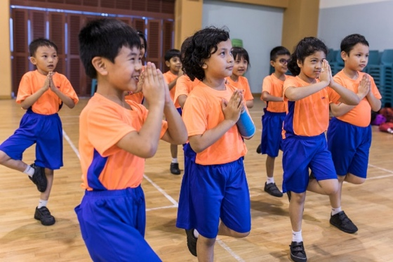We are pleased to invite you to KidsExcel @ Qihua Primary School, a year-long **Sports and Academic (English, Mathematics & STEM)** programme for Primary level pupils, helmed by trained and passionate teachers. Since 2012, KidsExcel has been held for more than 3,500 pupils.

**Programme Components**

**Academic Enrichment (1.5hrs):**

We aim to mould our pupils into confident, independent learners. Our classes revisit topics taught during school to give our pupils a chance to practice their understanding of the subject.

* English, Mathematics & STEM (science, technology, engineering, and mathematics)
* Designed in collaboration with NIE Experts
* Small Class Sizes – Banded to cater to different learning abilities
* Trained ex-MOE teachers and experienced tutors

**Sports (1.5hrs) :**

Physical activity helps children concentrate better in class. Through fundamental movement modules and modified games, we aim to develop the physical skills of our pupils and instil in them the importance of sportsmanlike behaviour.

* Instils intrinsic motivation
* Develops leadership skills & inculcates good character
* Includes: Fundamental Movement, Modified Ball Games, Modular Sports

**Programme Schedule**

|  |  |  |  |
| --- | --- | --- | --- |
| **Programme days** | Every Thursday | Every Wednesday | Every Thursday |
| **Level** | Primary 1 – Primary 2 | Primary 3 – Primary 5 | Primary 3 – Primary 5 |
| **Time** | 2.00 – 5.00pm | 2.00 – 5.00pm | 2.00 – 5.00pm |
| **Activity** | STEM + Sports | English + Sports | Maths + Sports |
| **Start date** | 27th March 2025 | 26th March 2025 | 27th March 2025 |

Pupils are to assemble at the school hall by 1.55pm.

The KidsExcel programme is open only to pupils nominated by Qihua Primary School.

**How to Register**

* Register online at <https://www.kidsexcel.net/qihuapri> or scan the QR code below to submit the registration form online.



* Alternatively, you may complete the registration form attached, and submit it at General Office or take a picture and send it via WhatsApp to the programme coordinator,

Ms Winnie @ 80571863.

* **Register by 7th March 2025.**
* Programme slots are assigned on a first come, first served basis.
* Children under financial assistance schemes will have **their programme fees fully subsidised**. Pupils receiving the subsidy must attend at least 80% of classes.

For more info, please contact Ms Winnie (programme coordinator) @ 80571863 or visit KidsExcel.net

## 

## Terms and Conditions

Copy of Terms and Registration on the registration form

1. **Right to attend**

* If the child is unable to attend due to valid reasons (e.g. illness), the parent/guardian should keep the company informed.
* Our company reserves the right to refuse enrolment into the KidsExcel programme or to withdraw a student without prejudice.
* MOE FAS students must attain at least 80% attendance each month. The student may be withdrawn from the programme should attendance fall below the 80% mark without a valid reason.

1. **Conditions for withdrawal after commencement of programme**

* One month’s notice is required for withdrawal.
* Withdrawal will only commence on the first day of the following month after receipt of the withdrawal notice in writing.

1. **Indemnity and Insurance**

* Parents will be responsible for declaring all illnesses, medical conditions, or physical disabilities of the child in the registration form.
* While all reasonably practicable precautions are taken to ensure the safety of the students, parents agree that they will not hold the company liable for any mishaps that may occur and will hold harmless or indemnify the company against such liability.
* All students are covered by an insurance scheme. Our company reserves the right to enrol students in a suitable insurance policy.

1. **Use of information**

* All personal information will be kept strictly confidential.
* All information, including photographic, video, audio or other recordings, and statistical data derived from your child’s participation in the KidsExcel programme, may be used for research, service development and promotional materials. This includes the academic results of your child and other assessment instruments used in the programme, and allowing the company to obtain the results of your child from the school.

The company reserves the right to use all intellectual property related to the **KidsExcel**programme for organizational and development purposes.